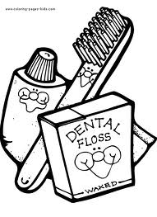
Parents and guardians,

This week your child is going to be learning about dental hygiene in class. In order to reinforce good health habits and the proper way to brush teeth, students have been given a chart to record when they brush their teeth. For one week, students can track when they brush their teeth, in the morning and at night. This is not required; however, students will receive a small reward if they bring in the completed chart. There are stickers included to complete the chart. When the chart is filled, please send it back to school so your child can receive his or her reward.

Thank you,
Miss Lash

Parents and guardians,

This week your child is going to be learning about dental hygiene in class. In order to reinforce good health habits and the proper way to brush teeth, students have been given a chart to record when they brush their teeth. For one week, students can track when they brush their teeth in the morning and at night. This is not required; however, students will receive a small reward if they bring in the completed chart. There are stickers included to complete the chart. When the chart is filled, please send it back to school so your child can receive his or her reward.

Thank you,
Miss Lash

